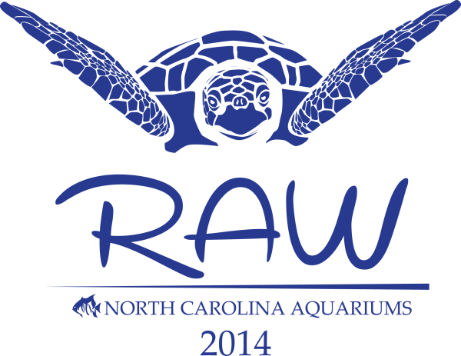
Call for
Presentations / Posters

Dear Colleague,

The staff of the North Carolina Aquariums would like to invite you to be an active participant in the 28th Annual Regional Aquatics Workshop (RAW) hosted by the North Carolina Aquarium at Fort Fisher, located on Kure Beach, NC. We encourage you to share your knowledge with your fellow colleagues by presenting your field of expertise to the group. Without many opportunities for formal training, public aquarists rely greatly on information sharing within the confines of our small, but highly skilled community to consistently improve our husbandry techniques for the well being of our captive collections. With a large variety of experience levels in attendance, from entry level aquarist to battle tested director, presentations are solicited to cover an array of topics. Program session topics may include but are not limited to the following:

Conservation, and Education · Exhibit & Life Support System Design · Legislation and Permitting · Collection, Acclimation and Quarantine · Nutrition and Feeding · Captive Behavior · Record Keeping · Reproduction · Veterinary Care · Water Quality Management · Enrichment – and a Back to Basics session where you can give us an overview of every day husbandry techniques that you have found works best for you over the years.

RAW will kick off this year on Monday April 21st with a day’s worth of AZA Aquatic (TAG) meetings. The next four days, April 22nd – 25th, will be paper sessions during which you are given the opportunity to share your new innovation or re-hashed old exploits with your fellow colleagues! There are (9) sessions planned with 4-5 selected talks per session, each talk is limited to a max of (20) minutes. If you need more incentive to wet you appetite for RAW 2014, see Registration Form for more details of the conference.

Email the completed Presentation / Poster Application form to:
RAW@ncaquariums.com

Deadline for Abstracts: Friday February 7th, 2014

